**10-minute: Become a key opinion editor**

**10**分钟让你成为科技媒体网红小编

* **The Overview of website data**

There are 3,721 authors contributing 21,348 articles. On October 20, 2012, 377 articles were published which is the highest number. But in this website, the number of favorites and likes are not too high. 75% of the articles just have 77 favorites, and the number of likes is only 23%. It means that different from Official Account of WeChat and other famous websites about business, woshipm.com does not have the high internet traffic.

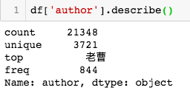

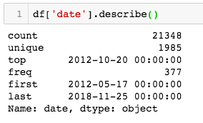

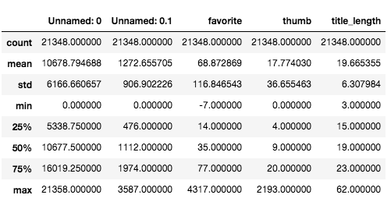

The author who publish most articles names LaoCao and he submitted 844 articles, then we found that LaoCao is the CEO of this website.

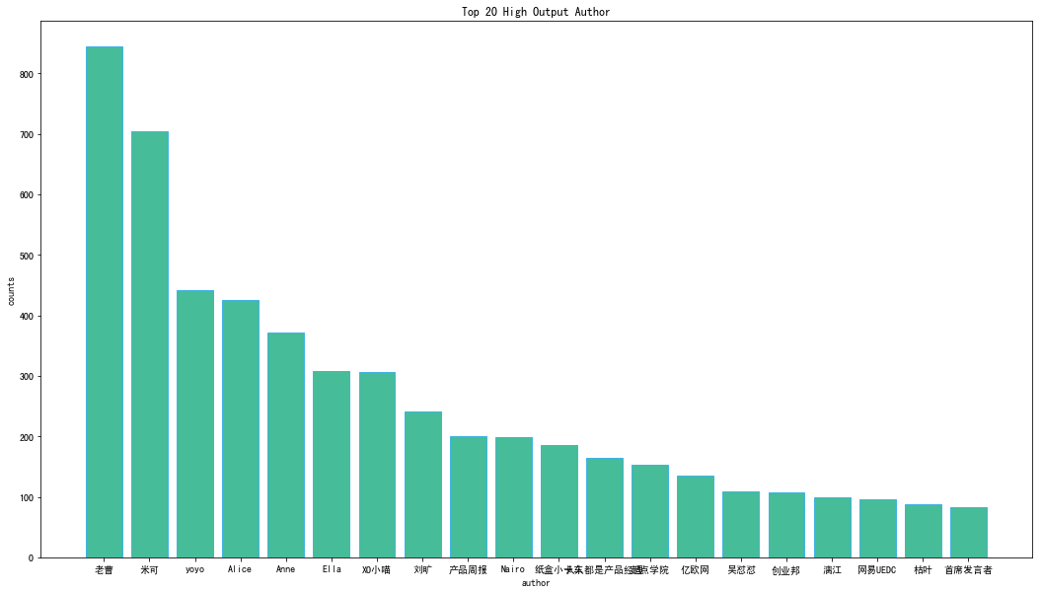

* **Data Analysis**

For a media editor, web traffic is the most important thing because it can show you this website is popular or not, and the standard to measure the popularity of a website can be the reading quantity, favorites, likes and so on. So editors may think that writing articles as more as possible can attract peoples’ attention and increase the reading, but we found that this consumption is not correct.

Ranking by the number of favorites, the authors who obtained the TOP10 favorites only wrote an average of 7 articles. According to the number of published articles, the authors who wrote the Top 10 articles only got an average of 45 collections.

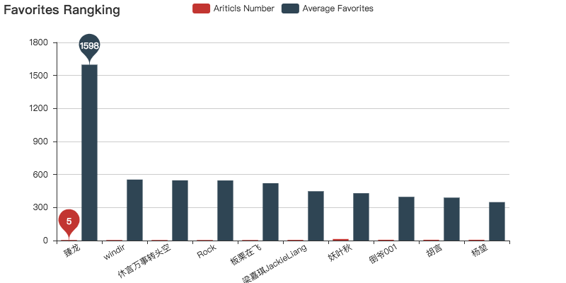

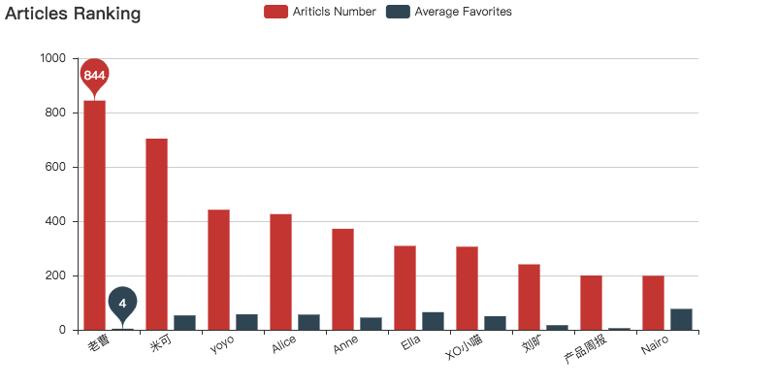

Taking Zhenlong and Laocao as an example, Zhenlong wrote a total of 5 articles, with the favorites up to 1600. Laocao wrote a total of 844 articles, but only got 4 favorites on average per article.

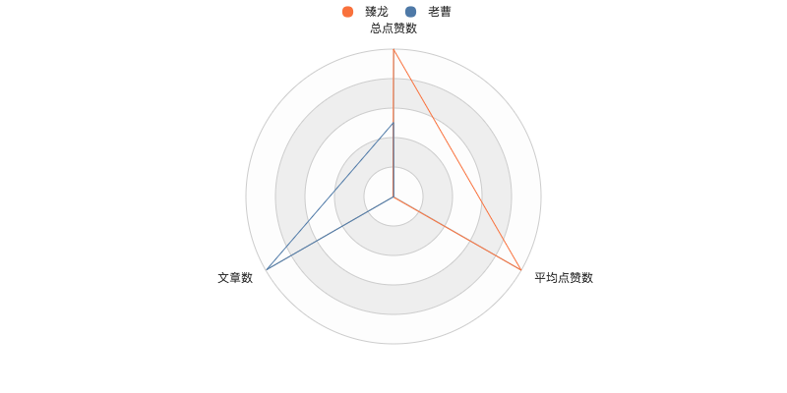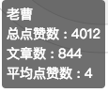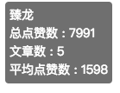

So, it does not mean that if you write more, you can get more attention. Nowadays we live in the world of information explosion, how should we let readers notice our articles?

**HOW TO WRITE? (writing skills)**

* **A good title helps a lot**

The data shows that the majority length of titles is from 10 to 30. what needs to be mentioned is that length around 20 would gain more favorites and thumbs. It is significant to have suitable title-length for writing.

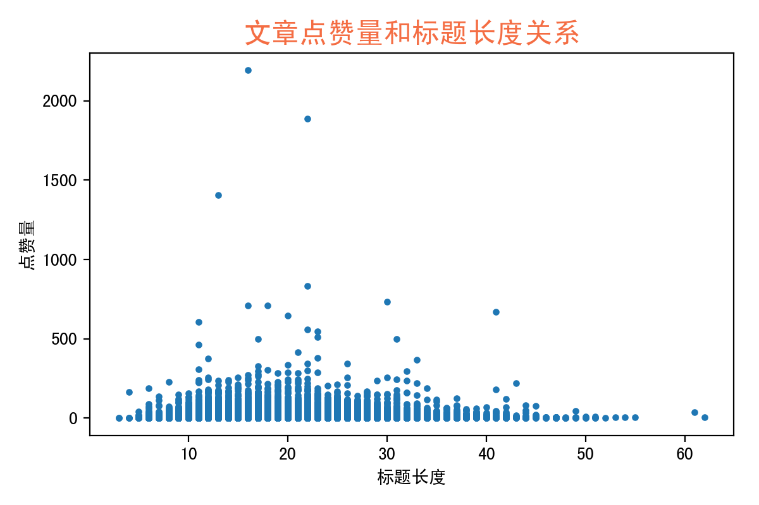

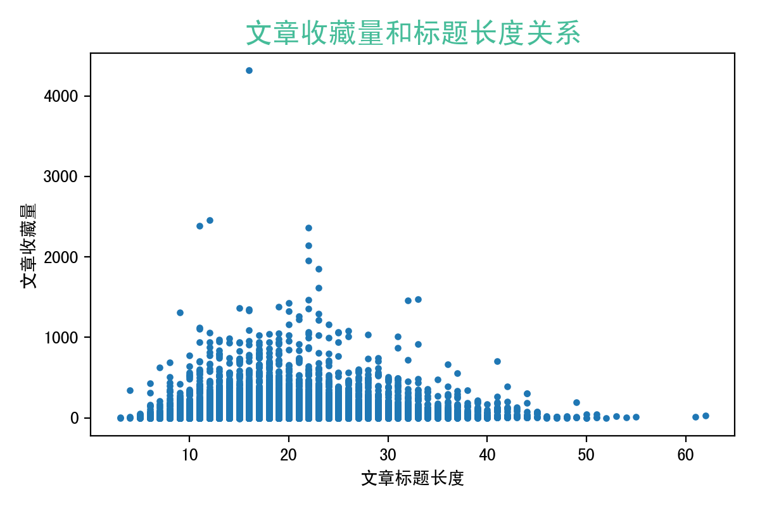

* **Example: (illustrate the importance of proper title-length)**

(1) News articles provide with various information. And people like reading those articles but most of the time, they would just read and close it, which means they would not take too much time to search it and prove it, thus have fewer favorites and thumbs. It shows clearly that those articles sometimes have long titles.

(2) Practical articles sometimes provide with different skills and opinions. And those articles give a chance for readers to practice and review, which means the readers are willing to collect them and search more information to prove or have a better understanding. They are different from those with long titles because they own suitable titles and gain more favorites and thumbs.

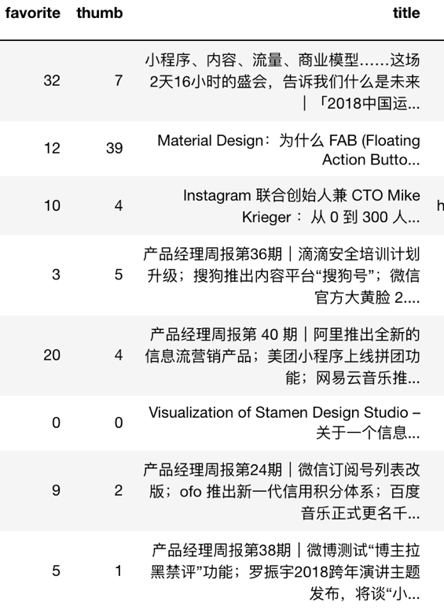 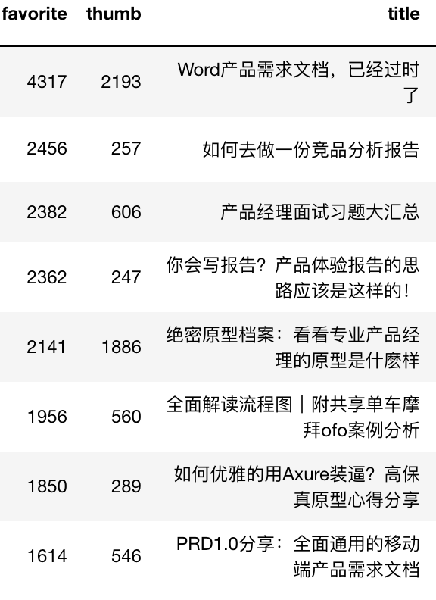

* **Punctuation of titles**

We found that the punctuation of titles can be diversified in this website, and the data shows that nearly one-third of titles use questions mark and few use exclamations mark.

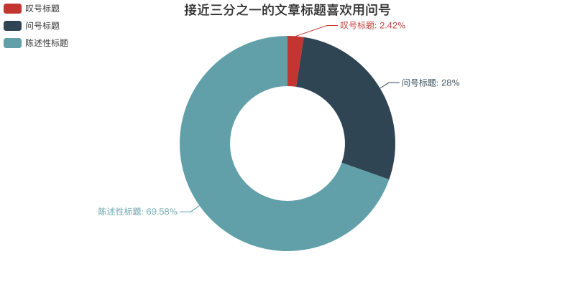

* **Whether use diverse punctuation can gain more favorites and thumbs?**

The answer is totally a surprise, as we count the average number of favorite and thumb with these title punctuation, the results are almost the same. The punctuation of articles are not related to the favorites and thumbs, writers can choose whatever punctuation they want.

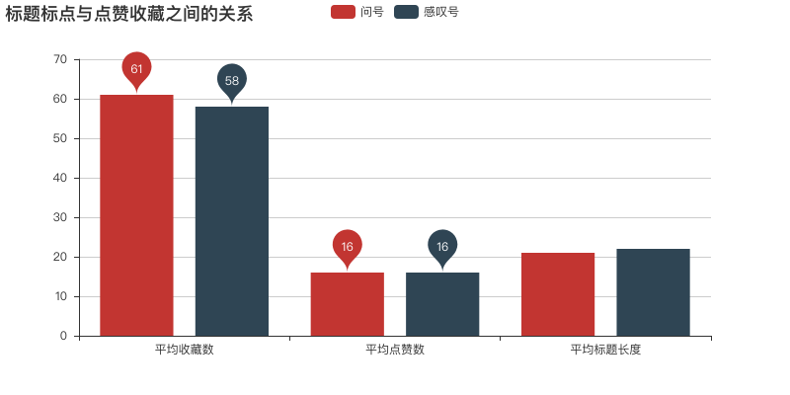

* **A good timing is also important**

The chart shows that the number of articles was divided into 4 quarters every year and it is clear that the third column is the highest one which has shown 5 times. It is said that quarter 3 is the peak of Article publication. And if you are a fledgling writer that do not want to have too much competition, then it is better for you to public your articles at Q1 or Q2.

However, if you want to gain more attention and it would be good to public at Q3 or Q4, as there would have more articles or writers show up to attract readers and you would have a chance to blockbuster.

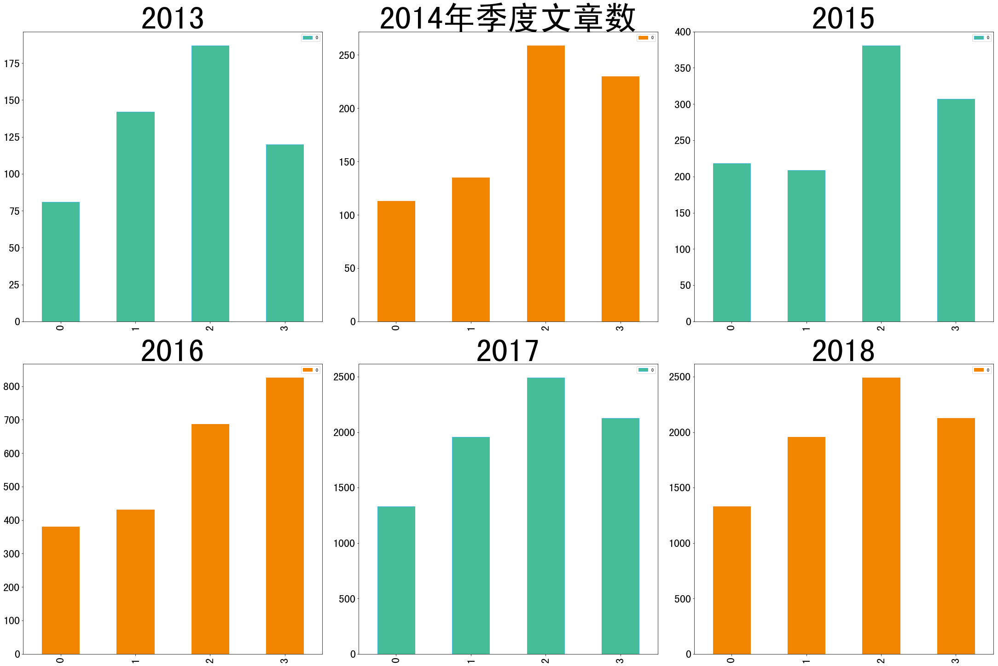

* **Why the number of publications grow rapidly from quarter 3 in 2016?**

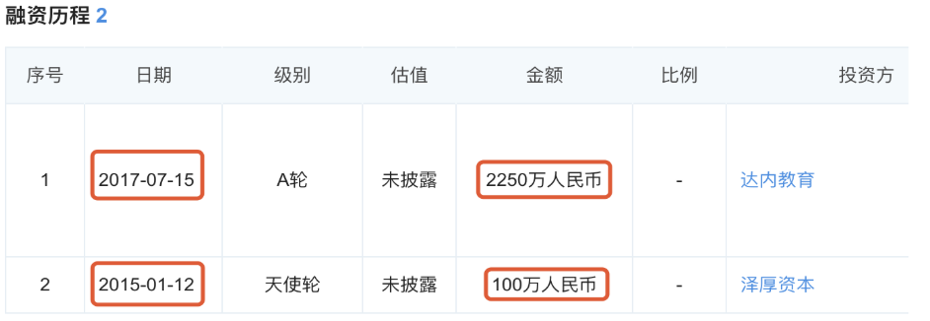

This platform had enterprise financing and gain a lot of money to support their service. What is more, they also have cooperative partnership with Tencent to be more and more popular. Thus, at that time, more and more writers public their articles on this website.

The information shows on the research is:

*“In July 2016, it won the first batch of certification bodies in Tencent's “TOP Plan”, and it reached a strategic cooperation with Tencent Classroom on IT Internet-Internet products and operations. It jointly launched “Tencent Classroom Product Academy”, which is strong to expand more and better-teaching content and innovative teaching mode in the product and operation fields.”[2]*

* **The number of published articles from 2012 to 2018**

The bar chart shows that the number of published articles has increased from 2012 to 2018, which means that this website is getting stable and popular, so it would be a good choice to public your articles on this platform as a key opinion writer in the area of technology and new media.

* **Walk out the comfort zone to see what the readers are interested in**

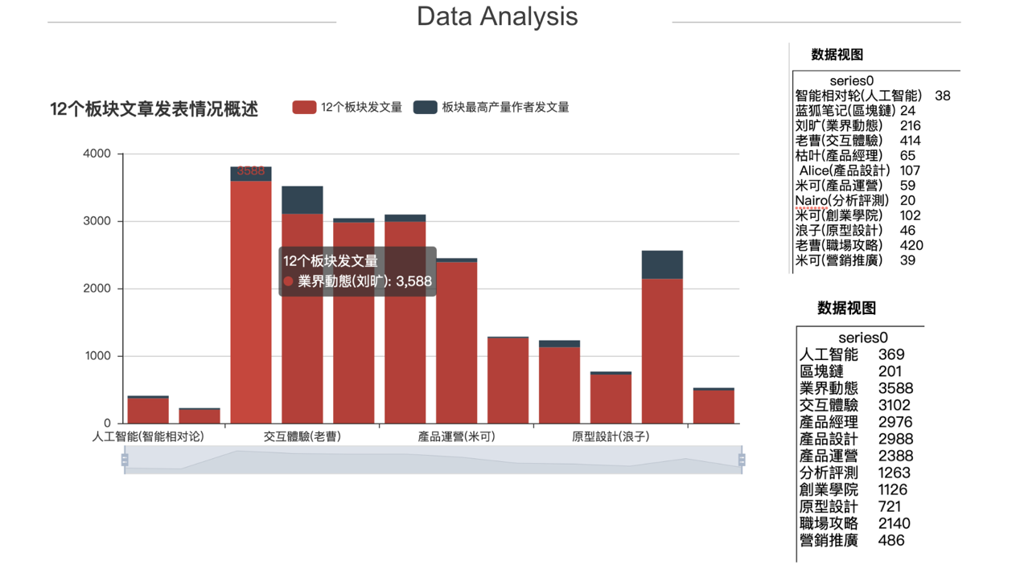

After analyzing all the articles in 12 categories. We find that LaoCao, the CEO shine again. He is the most productive author in two hot categories, interactive experience and workplace strategy. Because LaoCao is the CEO and also a product manager, we can know that these two topics are what he familiar with. However, as what we have already mentioned, he got only 4 thumbs for average, so we can conclude that to be a popular writer, we should not just focus on what we familiar, we should walk out to see what the readers are interested in.

* **How to get your articles noticed**

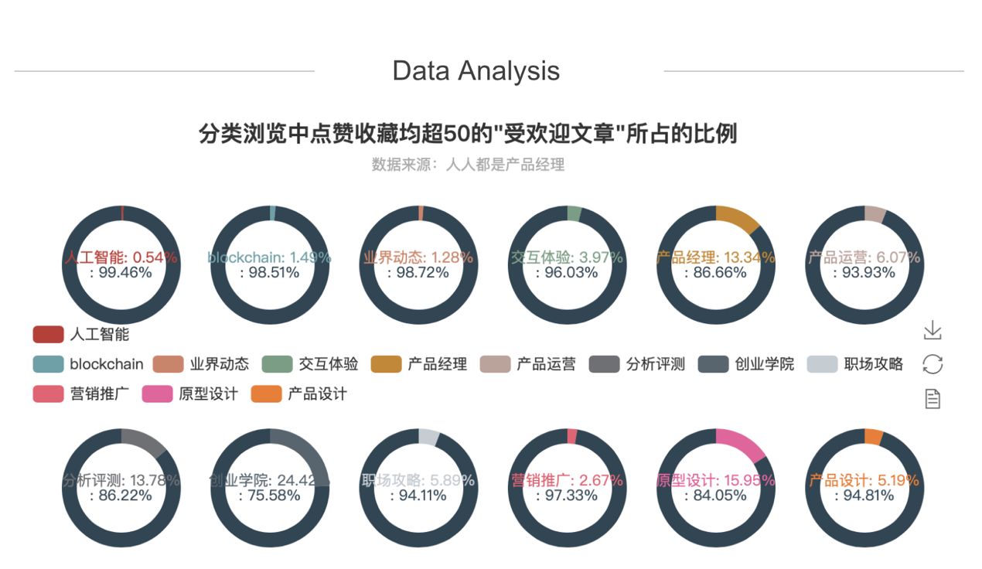

By doing research on the percentage of the popular articles, which means the articles with both of the favorite and thumbs more than 50, in 12 categories, we can tell which category are popular and which category should author write about to get success.

It’s obvious that the top 3 biggest shares of the popular articles appear in Analyzing and Evaluation, Entrepreneurship Academy and Prototype Design, which tells that these three topics are what the readers most interested in. At the same time, the total number of the articles in these three categories are all around 1000, so we can know that the competition in these three categories are not the most fierce, so it’s easier to get your articles popular and it’s a great chance to write articles in these three categories.

* **An example to explain how to avoid having few favoirtes while having lots of thumbs**

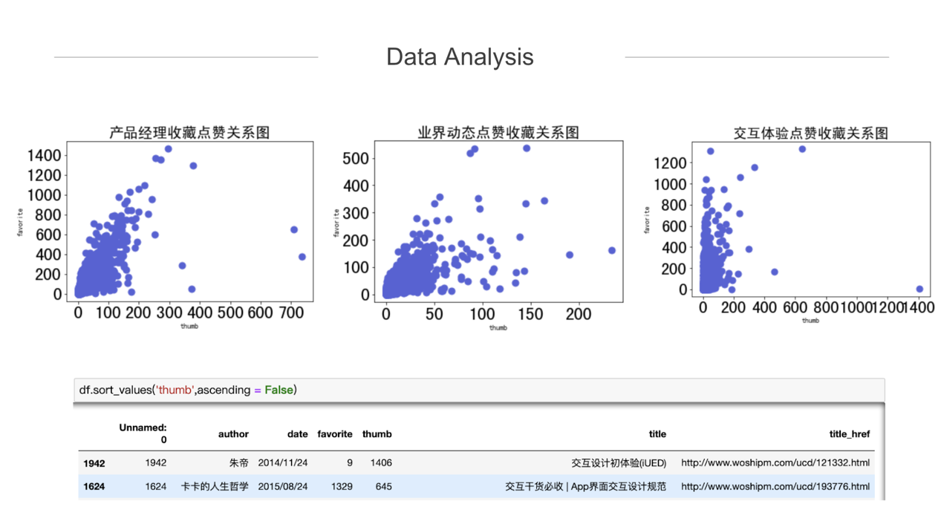

In terms of the relationship between the thumb and favorite of articles in the three hottest categories, Product Manager, News in Industry and Interactive Experience, where competition are the most fierce. The relationship is basically positive, but there is a very special article with the highest number of thumb but with very few favorites.

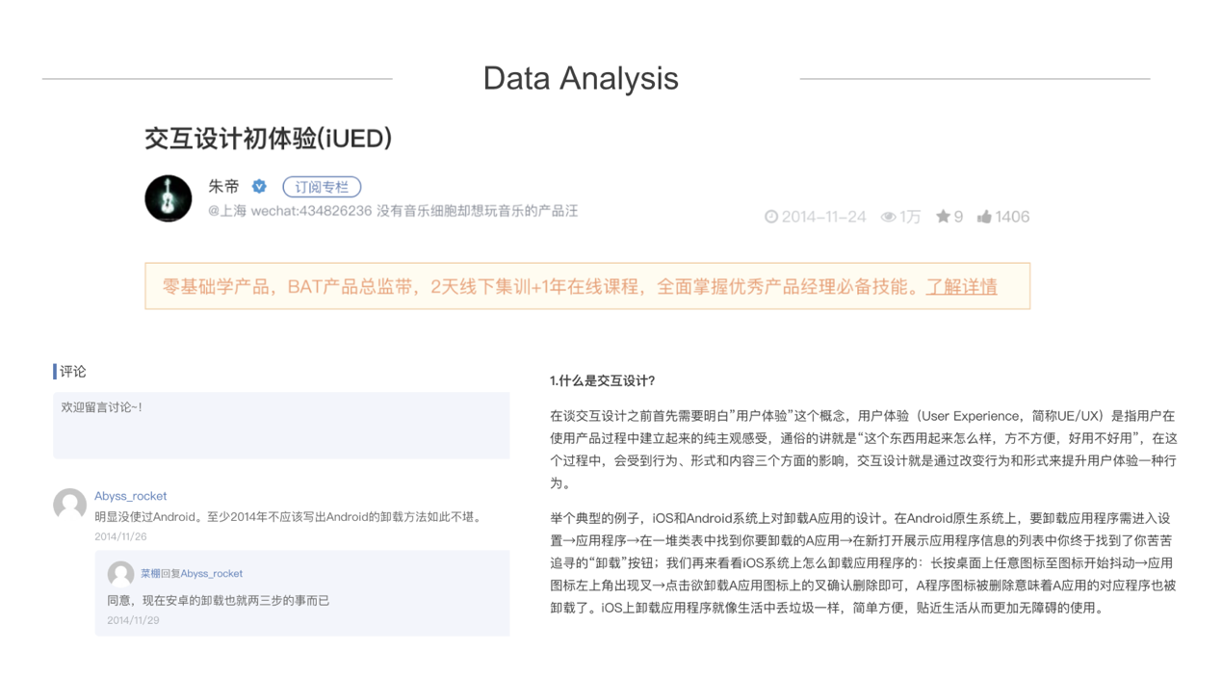

To understand why, we find out the article. The title of this article is the first experience of Interaction Design. According to the review, the reason is possibly about the content. There is an obvious mistake in this article. The readers might appreciate author's spirit of sharing. However, the mistake overshadows the article and this article is about the first experience, which means the knowledge in the article might be a little bit simple for the readers.

* **Summary**

In digital era, as a new media editor, it is necessary to be familiar with these words like Start-up, big data, AI etc. Besides, for a new media editor, it'll never be enough to only know words, but also need some skills in order to make articles popular. Ultimately, our report reveals how to become a KOL editor of [Telecommunications, Media and Technology (TMT)](https://www.pwccn.com/en/industries/telecommunications-media-and-technology.html) industry in 10 minutes.

This is the article we found with highest favorite and thumbs

(http://www.woshipm.com/rp/211554.html).

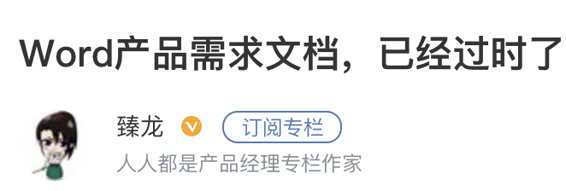

By looking through our Word Cloud, the high-frequency words of all titles, we can easily find a special word among it. To be more specific, it is an Internet company named Netease(网易). What surprises us most is that the result (Top 60 high-frequency words) actually doesn’t include the Internet companies which are Ali Group, Baidu or Tencent. And as we know, Netease is not Top 3 in this industry of China. However, compared with other companies, its products like Youdao Dictionary, CloudMusic and Public Class seems more attractive for product managers to study further, because all these applications have a great user agglutinant. Hence we suggest that editor could tap into Netease company to make a better connection with Chinese audience.



After completing the whole operational process, our team found a bug in the number of collection. There are 4 negative numbers when sort by favorite. We log in the website (http://www.woshipm.com/zhichang/9479.html

) to verify the bug. When clicking this button, we observe that the number has changed from -7 to -6.

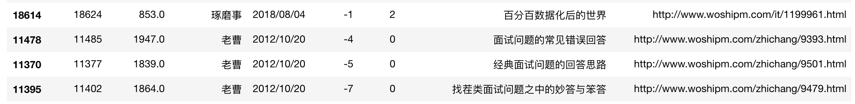

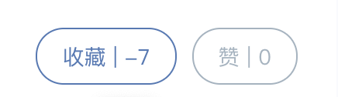

**Reference:**

[1] <http://www.woshipm.com/>

[2] <https://www.qichacha.com/product_ba3c25f5-e7c2-4418-bc1e-3657329f9f9a>

[3] <https://mp.weixin.qq.com/s/e7FJea7QEPOIkhJbu7yaLw>